 | 
Full Wave Rectifier
Name: Mohammad Omar Salameh – 2020240078
Mgs030@live.aul.edu.lb
Course: CCE214 Electronics I
Instructor: Dr. Engr. Khaled Mouchref
Academic Year: 2026-2027
Fall 2026

Table of Contents
1. Introduction 3
3. Required Components and Equipment 3
4. Basic Circuit 3
5. Working Principle 4
5.1 Positive Half-Cycle 4
5.2 Negative Half-Cycle 4
6. Main Calculations 6
6.1 Average DC Output Voltage 6
6.2 RMS Output Voltage 6
6.3 Peak Load Current 6
6.4 Peak Inverse Voltage 6
10. Advantages and Limitations 6
Advantages 6
Limitations 7
11. Applications 7
13. Conclusion 7

1. Introduction
A full-wave bridge rectifier is an electronic circuit that converts an alternating-current (AC) signal into a one-directional, pulsating output by using both halves of the input waveform.
The circuit uses four diodes arranged in a bridge. During each half-cycle, two diodes conduct while the other two remain reverse biased. The direction of current through the load remains the same for both halves of the AC cycle. This project demonstrates diode conduction, forward and reverse biasing, full-wave rectification, output frequency, and the main electrical quantities of the bridge rectifier.
3. Required Components and Equipment
Item | Suggested Value / Type | Purpose
AC source | 10 V peak, 50 Hz function generator | Provides the sinusoidal input
Diodes | 4 × 1N4007 | Forms the bridge rectifier
Load resistor | 1 kΩ | Represents the load
Oscilloscope | Two-channel | Displays input and output waveforms
Digital multimeter | DC/AC measurement | Measures voltage and current
4. Basic Circuit
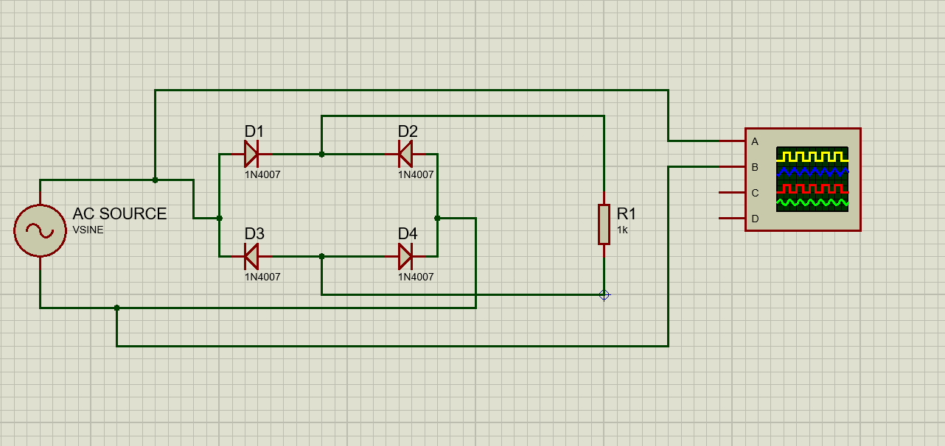
Figure 1-Proteus Simulation
The four 1N4007 diodes are connected in a bridge configuration and the output voltage is measured across the 1 kΩ load resistor. In Proteus, the AC source is set to 10 V peak and 50 Hz. Two diodes conduct during each half-cycle, so the load current keeps the same direction throughout the complete AC cycle.

5. Working Principle
5.1 Positive Half-Cycle
When the left AC terminal becomes positive with respect to the right terminal, one diagonal pair of diodes becomes forward biased. Current flows from the AC source through the first conducting diode, through the load resistor, and then returns through the second conducting diode. The other two diodes are reverse biased.
Because two silicon diodes are in the conducting path, the total forward voltage drop is approximately 1.4 V under ordinary laboratory conditions.
$$V_{out} ≈ V_{in} - 2V_{D}$$
$$For silicon diodes: V_{out} ≈ V_{in} - 1.4 V$$

For example, if the input peak voltage is 10 V:
$$V_{out}(peak) ≈ 10 - 1.4 = 8.6 V$$
5.2 Negative Half-Cycle
When the AC input reverses polarity, the opposite diagonal pair of diodes becomes forward biased. Current again passes through the load resistor in the same direction. Therefore, the negative half-cycle of the source is inverted at the output instead of being blocked.
Vout ≈ |Vin| − 1.4 V when |Vin| > 1.4 V
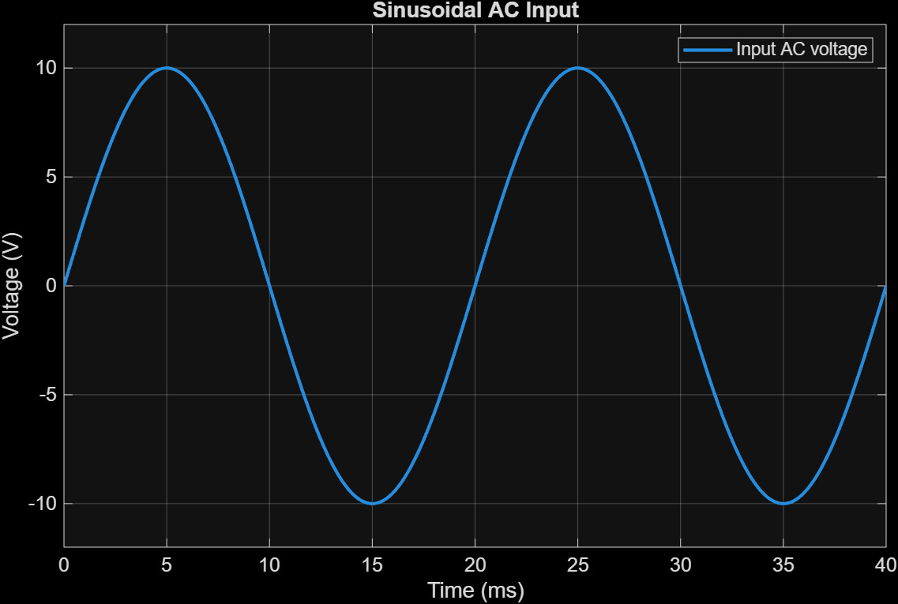
Figure 2Sinusoidal AC input voltage.
The equation used is:
$$v_{in}(t) = 10 sin(2π(50)t)$$
So the waveform has:
- Peak voltage is 10 V
- Peak-to-peak voltage is 20 V
- Frequency: 50 Hz
- Period: 20 ms
At t = 5 ms, the voltage reaches approximately +10 V; at 15 ms it reaches −10 V; and the complete input waveform repeats every 20 ms.
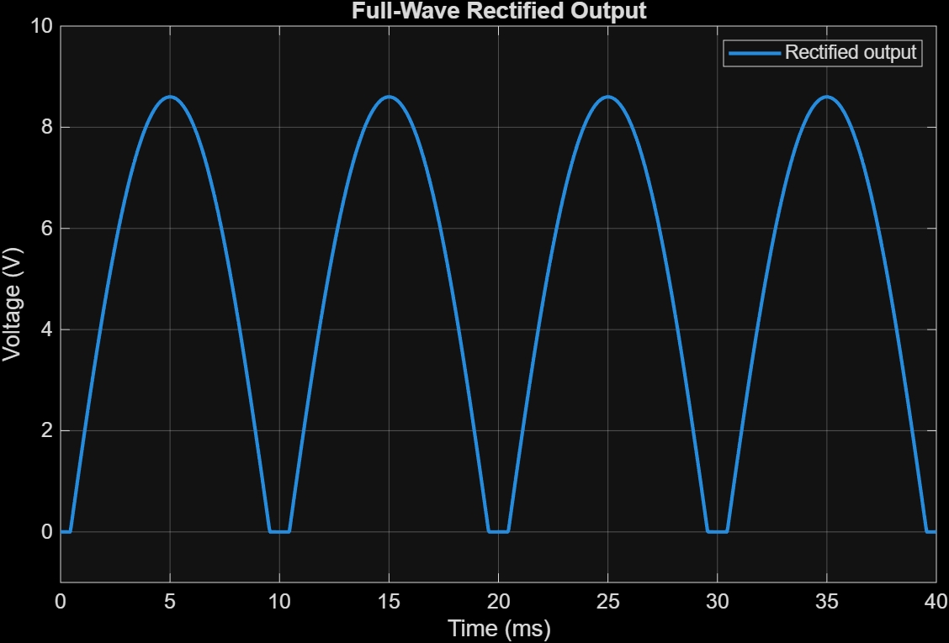
Figure 3Full-wave rectified output. Both half-cycles appear as positive pulses

This models the bridge-rectifier behavior. During the positive half-cycle, one pair of diodes conducts. During the negative half-cycle, the opposite pair conducts. In both cases the load current has the same direction.
$$V_{out} ≈ |V_{in}| - 1.4 V$$
With a 10 V peak input, the maximum output voltage is approximately:
$$V_{out}(pk) = 10 - 1.4 = 8.6 V$$
Since both half-cycles are rectified, the output contains two pulses for every input cycle. Therefore, a 50 Hz input produces an output ripple frequency of:
$$f_{out} = 2f_{in} = 2(50) = 100 Hz$$

6. Main Calculations
For an ideal full-wave rectifier with a sinusoidal input having a peak value of Vm:
6.1 Average DC Output Voltage
$$V_{DC} =\frac{2V_{m}}{π} ≈ 0.637 V_{m}$$
Assuming that Vm = 10 V:
$$V_{DC} =\frac{2\left(10\right)}{π} ≈ 6.37 V$$
6.2 RMS Output Voltage
$$V_{RMS} =\frac{V_{m}}{\sqrt{2}}$$
For Vm = 10 V:
$$V_{RMS} =\frac{10}{\sqrt{2}} ≈ 7.07 V$$
6.3 Peak Load Current
$$I_{m} =\frac{V_{m}}{R}$$
For Vm = 10 V and R = 1 kΩ = 1000 Ω, the ideal peak current is:
$$I_{m} =\frac{10}{1000} = 0.010 A = 10 mA$$
Including the approximate 1.4 V total drop across the two conducting diodes:
$$I_{peak} ≈\frac{10-1.4}{1000} = 8.6 mA$$
6.4 Peak Inverse Voltage
Peak inverse voltage (PIV) is the maximum reverse voltage that each diode must withstand while it is not conducting. For a bridge rectifier without a filter capacitor, the required PIV for each diode is approximately equal to the peak input voltage.
$$PIV ≈ V_{m} ≈ 10 V$$

10. Advantages and Limitations
Advantages
- Both halves of the AC waveform are used.
- Higher average DC output than a half-wave rectifier.
- Output ripple frequency is twice the input frequency.
- Better transformer utilization and rectification efficiency.
Limitations
- Four diodes are required.
- Two diode forward-voltage drops appear in the conducting path.
- The unfiltered output is still pulsating DC and contains ripple.
- A filter capacitor is needed when a smoother DC output is required.
11. Applications
- DC power supplies.
- Battery chargers.
- AC-to-DC adapter circuits.
- Educational laboratory experiments for studying diodes and rectifiers.
- Input stages of regulated electronic power supplies.
13. Conclusion
The full-wave bridge rectifier shows how four PN-junction diodes can convert both halves of an AC waveform into a one-directional output. During each half-cycle, a different pair of diodes conducts while the current through the load remains in the same direction. As a result, the circuit makes better use of the AC input than a half-wave rectifier and produces an output frequency that is twice the source frequency. For a 10 V peak, 50 Hz input, the practical output peak is approximately 8.6 V because two silicon diodes conduct at the same time, while the rectified pulse frequency is 100 Hz. The experiment provides a direct connection between diode theory, waveform analysis, Proteus simulation, and the operation of the rectifier stage used in practical DC power supplies.

